Cherry blossom,

**GETTING STARTED GUIDE FOR FIRST RUN**

**Rev2**

**20210321**

## What Is ****Cherry blossom****?

Cherry Blossom is a single-board computer running embedded Linux. It has onboard eMMC that contains the Linux OS, as well as a microSD slot to run a different OS, or burn it to the eMMC. It has lots of I/O pins, including analog-to-digital converter (ADC) and pulse-width-modulation (PWM) pins. It also has an HDMI output, a USB plug (for a camera, keyboard/mouse, etc.) and another USB for connection to a computer, ethernet, on-board LEDs, and a 5V input jack all Via Stacker board enhancements

This guide will cover everything you need to know to get started with your Cherry Blossom, including SSHing to it from your computer, connecting to the internet from your Cherry Blossom through your internet connected computer, and getting started using the onboard Linux OS.

## What You Need

**Pre requests**

**Mini usb b cable**

**External 5V 2A (specifically needed when using HAT boards)**

**Etherrnet cable , for Ethernet Hat**

FTDI driver install

Ftdi FT232R TTL Cable

<https://etcher.io/>

Download images at

https://github.com/ccoetzee2380/Cherryblossom.git

## Loading Image to card,

Loading the images on SD car you will need to use Etcher program, ensure the SD card is the only external storage on the system before continuing. Follow steps as per etcher program , recommendation is to use the IOT image for requirements that want to use the on board EMMC . If the requirement is more resource intense , it is recommended to use a class10 16GB SD card high temp grade for longer operation and life conditions. Industrial SD card

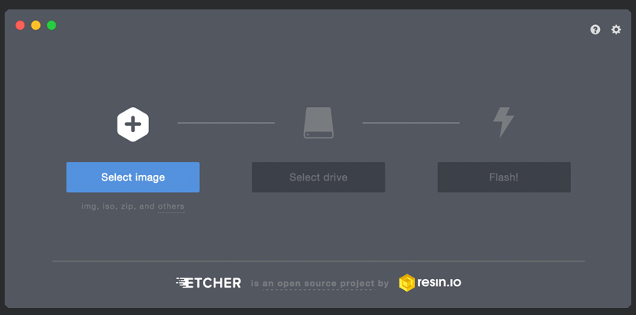

## Starting Up the board

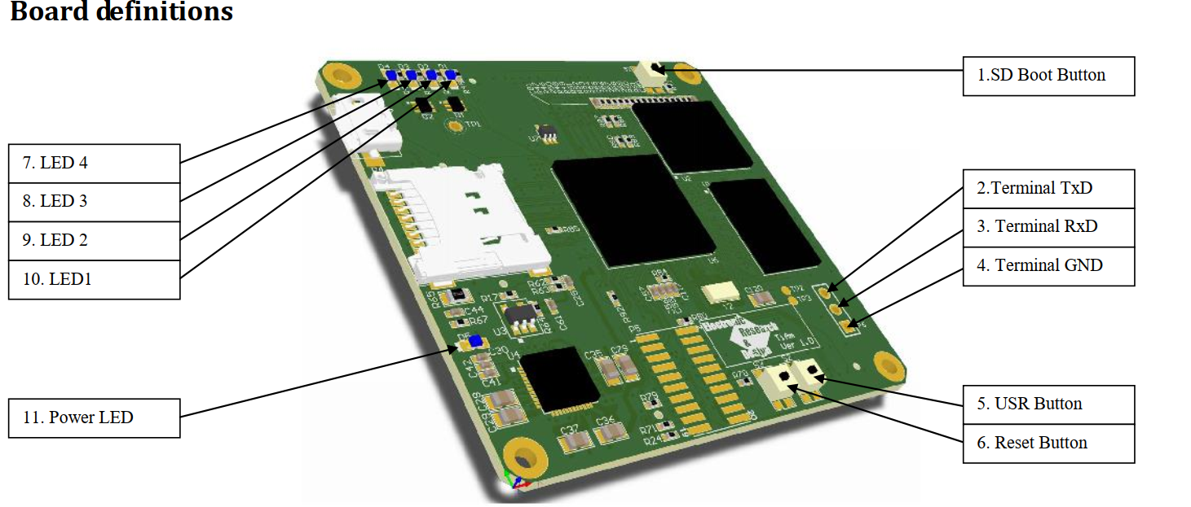

Before connecting USB cable , press the reset and SD boot button together.

While the buttons are pressed, insert USB cable

Once cable is inserted release buttons, it will take a while but it will enumerate a USB Ethernet connection under windows. “RNDIS” description

It is best to use the command line environment to determine the network interface over USB,

It will give you your IP address and the IPAddress of a gateway, Use Putty or similar program to access the unit by using the gateway ip address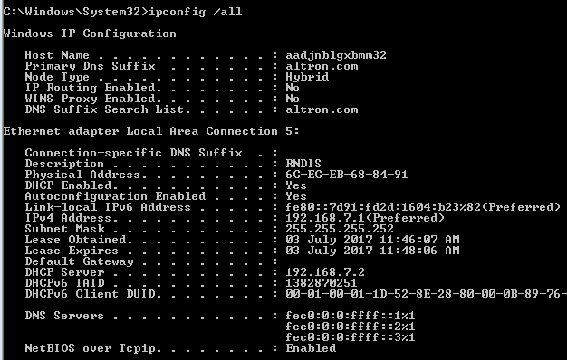

The unit also enumerates a USB to serial interface , Putty can also be used to access the unit through serial

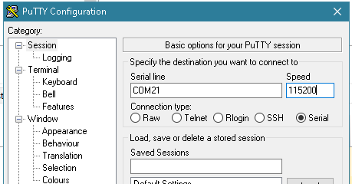

When connection is established, use the following username and password

username: cherry

password: blossom

or

username: debian

password: temppwd

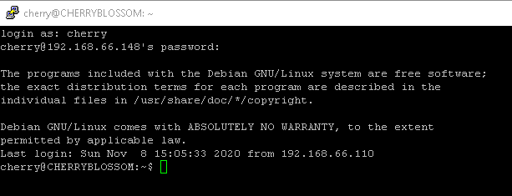

After password success you need to do the next steps in root access

Type **su root** and then for the password type **blossom** again.

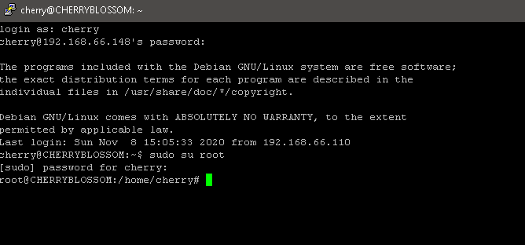

NOTE , not compulsory but recommended for IOT image

It is recommended to load a develop all applications first before you do the next steps , this way the image will be loaded with all you programs loaded on the internal memory

Navigate to the directory as below image shows



Once in the directory edit the following file



Unmask the very last line in the file , this will cause the unit to load the image on the SD card to internal memory



Save the change and exit

Now type reboot



Once reboot is done , leave the SD card inserted and remove the power

Give it about 5 seconds,

Hold Reset button and insert the USB cable. Once USB cable is inserted ,release reset and SD boot button. The board will start up and the LED will go a bit crazy / running LED for a while the image is transferred to the EMMC internal memory.

Once all this is done ALL LEDS may be on or off, restart the device and REMOVE the SD card.

If all LEDS flash there was a error in transfer of image to emmc. Possible reason onboard memory is too small for image

Add a new SD card that does not contain an image for extra storage.

## Re-Flashing the Onboard EMMC

If you break something in the Cherry Blossom's file system, you may have to reflash the onboard eMMC, the memory that holds the OS.

First, download a new image. Depending on your connection, the download may take a while; it's quite big. Meanwhile, download 7-zip from [here](http://www.7-zip.org/download.html), selecting the proper version from the list. Install it, as you will need it to unzip the Cherry Blossom's image. When the image is done downloading, open it with 7-zip (it will be a .xz file), and extract it somewhere you will find it. Next download SDFormatter [here](https://www.sdcard.org/downloads/formatter_4/) and install, and Win32DiskImager from [here](https://sourceforge.net/projects/win32diskimager/), and install (don't you just love all these little tools?). Insert you sd card into your computer and open SDFormatter. Format your sd card, making sure it is actually your sd card in the dropdown box. When that is done, open Win32DiskImager, click the browse button on the right, and find the extracted file. Select the file, select your sd card in the other dropdown box, and click write. This will take a while, so go find a snack, take a nap, and binge-watch your favorite TV show.

When it is done, you will have to shutdown your computer and boot into a live Linux USB or CD (other tutorials are online explaining how to do so). When Linux loads, find your sd card, and open /boot/uEnv.txt, and find the line that says:

**##enable BBB: eMMC Flasher:  
#cmdline=init=/opt/scripts/tools/eMMC/init-eMMC-flasher-v3.sh**

and change it to:

**##enable BBB: eMMC Flasher:  
cmdline=init=/opt/scripts/tools/eMMC/init-eMMC-flasher-v3.sh**

Save it, and then eject the sd card. Plug it into your Cherry Blossom's sd card slot, and power it up, holding the Boot button until you see the LEDs light up. The LEDs should start to blink back and forth. If they are, then the Cherry Blossom's is flashing the new image to the onboard eMMC. Now wait. Find another snack and finish binge-watching your show. Come back when the lights are dark, and remove the sd card. Mark the sd card in some way to remind you that it is a flasher, or edit to line back to the original. Because you can also boot into the sd card without flashing, you don't want to accidentally reflash your Cherry Blossom's.